333D01 Functional Tester User Guide

Purpose
333D01-TS1 is a single point functional tester for the 333D01. The intent of its creation is to perform a basic single point functional test on a 333D01 sensor. The document is a general guide to the various options and readouts the software provides.
This guide is written for version 1.0.0 of the application.
The application will also serve as a demo of a Windows application interfacing to the 333D01 sensor using LabWindow/CVI.

Overview
This provides a figure of the single page application. The following sections will provide more detail on the functionality.
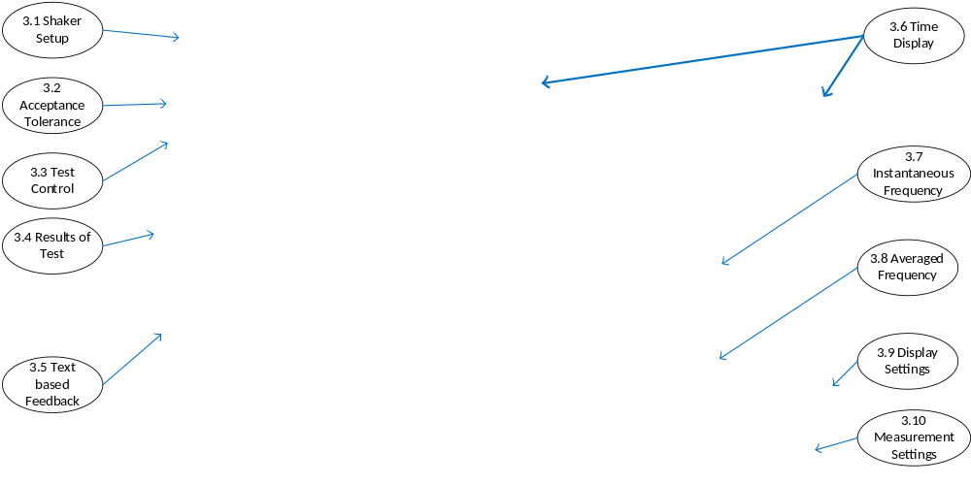

Detailed Descriptions
The following sections will provide functional details on the various graphical user interface sections identified in the previous figure.

Shaker Setup
The shaker section allows the application to adapt the success criteria to specific calibration shaker characteristics. The common portable vibration source at PCB is 1 gRMS and 159 Hz so that is the default.
The expected amplitude can be specified.
Units of g or g RMS can be selected.
The expected frequency can be specified.

Acceptance Tolerance
Because success criteria can and does change over the life of a project, the application allows the pass/fail tolerance to be controlled by the test procedure and not locked into the application executable.
The default is 15%.

Test Control
The ‘Test Sensor’ button will start a test. While the test is executing, it can be used to cancel the test. This area provides a progress bar for the 30 averages as the test is run.
Some of the following error messages are possible:
Error message of ‘A 333D01 sensor is not found.’ This can because the sensor is not attached or because of a hardware failure. The application searches for a recorder source that has 333D in its name. This is to account for early sensors that just had the model number 333D.
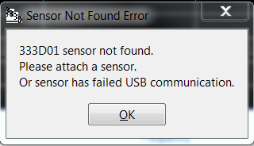
Error message of ‘This application will only test the first 333D01 sensor found in the audio device list’. The typical usage of this test program is with a single sensor. It just provides the following warning if multiple sensors are attached. It just tests the first sensor in the list provided by Windows audio system. The order is indeterminate so the recommendation is to disconnect the additional sensors.
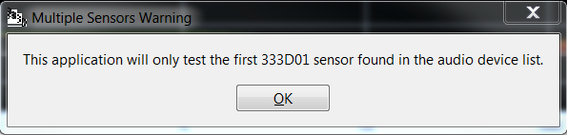

Results of Test
The results section displays the average counts per m/s² at the frequency specified in the ‘Shaker’ setup and normalized to Counts per m/s² using the amplitude specified in the ‘Shaker’ setup section.
Note: This calculation does not use ‘Display Sensitivity’ and only uses the raw data.
For channel 1, the expected results are 36000 counts nominal. The actual counts measured from the average spectrum will be displayed.
For channel 2, the expected results are 70000 counts nominal. The actual counts measured from the average spectrum will be displayed.
The ‘Pass/Fail Tolerance’ is used as the success criteria. Both channels must be within the +/- the pass/fail tolerance for the result indicator to be green.

Text Based Feedback
Status related information is displayed in the feedback window. It displays the number of sound devices found and a truncated description string for the 333D01 being tested.
It returns some diagnostic information such as the g reading at the shaker frequency and estimated accelerometer pellet sensitivity in mV/g. The voltage scaling used is derived from only 3 boards so it should not be considered anything but a rough estimate of sensitivity.

Time Display
The time data from each channel is displayed. This data can be used to verify there are no data drop outs and that both channels are reading data properly. The display will auto scale to input amplitude.
The sensitivity used for the time and frequency displays are the values specified in the ‘Display Sensitivity’ field (Section 3.9). This application is designed to test uncalibrated sensors so this field normally is just the nominal sensitivity. The time and frequency displays are primarily for qualitative confirmation the sensor is producing valid samples.
The pass/fail criteria are determined from the unscaled waveform and do not include the display sensitivity in the calculations.
Note: If an accurate display needed, the exact sensitivity for the sensor can be entered into the ‘Display Sensitivity’ field (Section 3.9) and the measurements repeated.
The display will be scaled to units selected in the shaker menu (Section 3.1).

Instantaneous Frequency Display
The spectrum window shows the frequency spectrum of each acquired data block. The display will be in dB peak relative to 1g peak.
The spectrum is calculated using a max flattop signal processing window.

Averaged Frequency
The averaged frequency window displays a linear average of the input frequency data. The display will be in dB peak relative to 1g peak.
The average spectrum is calculated using a max flattop signal processing window.
The average spectrum is used for calculating the results.

Display Settings
As a convenience for testing an uncalibrated sensor, the displays (time and frequency) use a nominal sensitivity specified in these fields.
Note: The pass/fail criteria are determined from the unscaled waveform and do not include the display sensitivity in the calculations.
This field can be updated to use the calibrated sensitivity if there is a need for more accurate displays.

Measurement Settings
As an aid in understanding the displays and results, the hard coded acquisition and calculation parameters are displayed.
The resolution is 16 bits (this is the default for the sensor when first plugged into Windows XP).
The sample rate is 8000 samples / second (default for sensor).
Block size is 2048.
Window is Max Flattop (best accuracy for sine wave excitation).
The test performs 30 linear averages.

